An employee requests installation of licensed software through the Service Catalog

Name: THOKALA MEENAKSHI
Email: 23JR1A05F6@KITSGUNTUR.AC.IN
College: KKR&KSR INSTITUTE OF TECHNOLOGY AND SCIENCES
Project Name: LICENSED SOFTWARE REQUEST SOLUTION
Introduction
This project is developed using the ServiceNow platform to automate the process of requesting licensed software. Employees can submit software requests through the Service Catalog, and the requests follow an approval process before they are assigned to the IT team for installation.
The main goal of this project is to reduce manual work, improve efficiency, and ensure that software requests are approved and completed in a structured and secure manner.
Implementation:
- Requirement Analysis
Business Objective
Enable a self-service software installation request process for employees via the Service Portal while ensuring proper approvals and security checks are completed before fulfillment.
Key Rules & Workflow Constraints:
• Catalog Item: Employees submit a software request using a standardized catalog item.
• Manager Approval: Every submission requires approval from the employee's direct manager.
• Conditional Software Asset Approval: Requests for Licensed software require approval from the Software Asset Management (SAM) team.
• Fulfillment Task: Upon all required approvals, a Catalog Task (sc_task) is automatically generated and assigned to the IT Software Support group.
• Lifecycle Automation: Marking the task as Closed Complete automatically sets the parent Request Item (RITM) state to Closed Complete.
2. Order of Operations
Step 1: Create and Set Update Set
Step 2: Create Catalog Item
Step 3: Configure Catalog Variables
Step 4: Create Catalog UI Policy
Step 5: Build Flow Designer Workflow
Step 6: Link Flow to Catalog Item & Test Submissions
3. Step-by-Step Configuration Guide
Step 1: Initialize Local Update Set
Navigate to System Update Sets > Local Update Sets.
Click New.
Set Name to: Software Request Implementation v1.0
Click Submit and Make Current.
Step 2: Catalog Item Creation
Navigate to Service Catalog > Catalog Definitions > Maintain Items.
Click New.
Configure:
Name: Request Licensed Software Installation
Catalogs: Service Catalog
Category: Software
Short Description: Submit a request for desktop or enterprise software installation.
Description: Use this form to request installation of standard or licensed software.
Click Save.
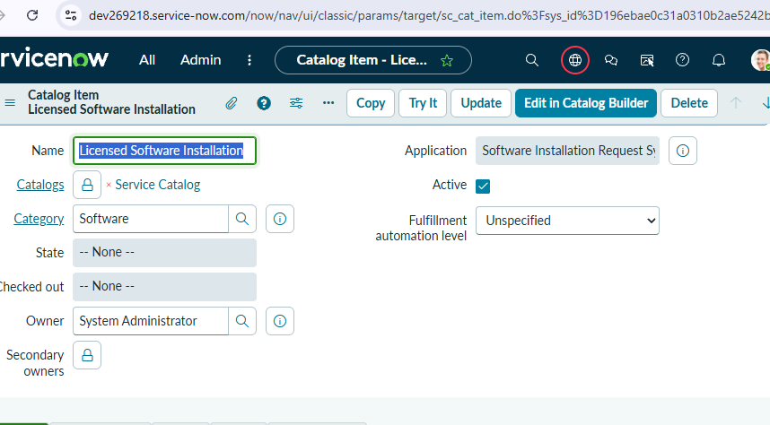
Step 3: Variable Configuration
Requested For
- Type: Reference
- Name: requested_for
- Reference Table: User (sys_user)
- Default: javascript:gs.getUserID()
- Mandatory: True | Order:100
Software Name & Version
- Type: Single Line Text
- Name: software_name
- Mandatory: True | Order:200
License Category
- Type: Choice
- Name: license_category
- Choices: Free, Licensed
- Mandatory: True | Order:300
Cost Center
- Type: Reference
- Name: cost_center
- Reference Table: Cost Center (cmn_cost_center)
- Mandatory: False | Order:400
Business Justification
- Type: Multi Line Text
- Name: business_justification
- Mandatory: True | Order:500
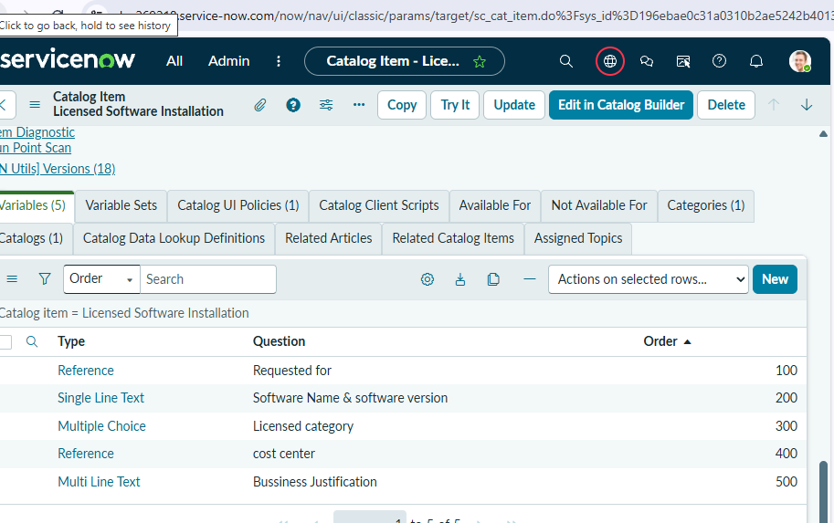
Step 4: UI Policy Configuration
Short Description: Mandatory Cost Center for Licensed Software
Condition: License Category IS Licensed
UI Policy Action:
Variable: cost_center
Mandatory: True
Visible: True
Step 5: Flow Designer Setup
Flow Name: Software Installation Fulfillment Flow
Trigger: Service Catalog
Workflow:
1. Get Catalog Variables
2. Manager Approval
- If rejected → RITM = Closed Rejected
3. If License Category = Licensed
- SAM Approval
- If rejected → RITM = Closed Rejected
4. Create Catalog Task
Assignment Group: IT Software Support
5. Wait until sc_task = Closed Complete
6. Update RITM = Closed Complete
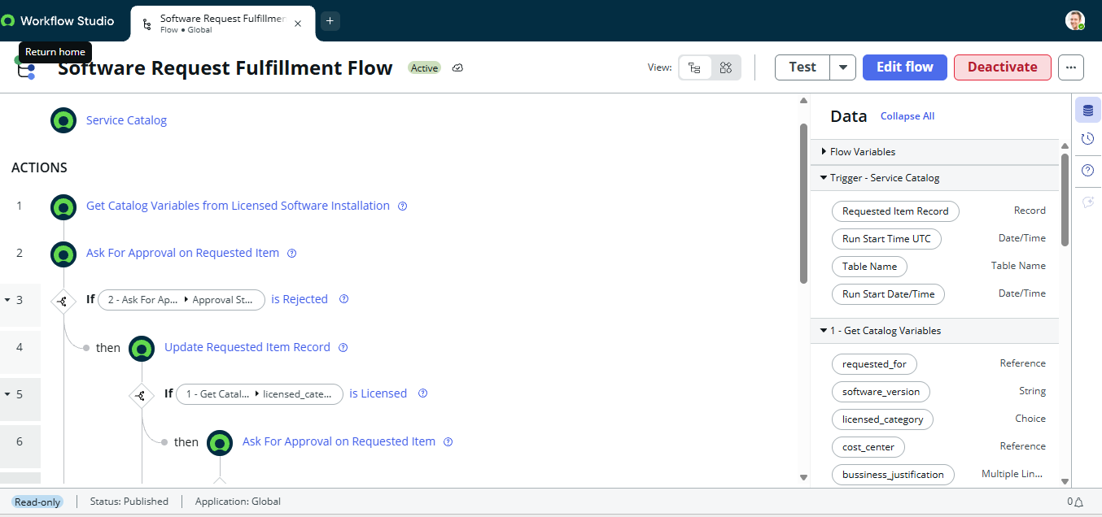
4. Test Submission Data & Validation Matrix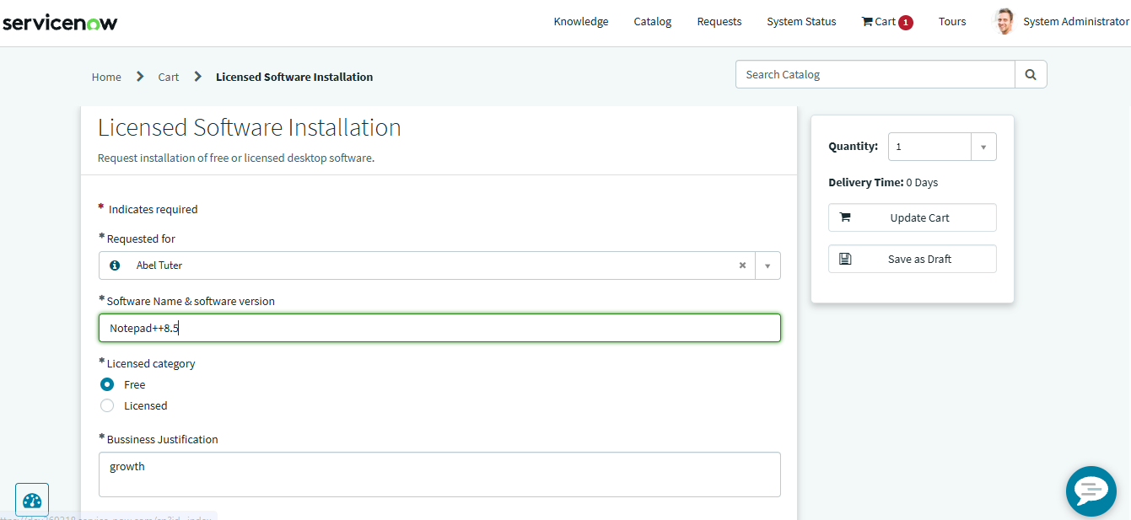
Test Case : Software Input: Free, Notepad++
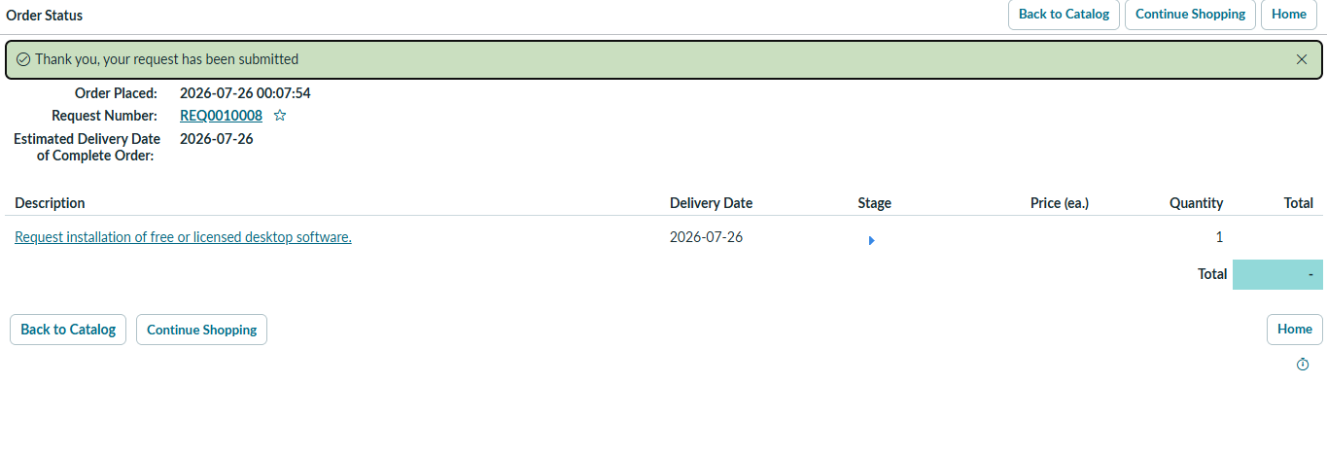
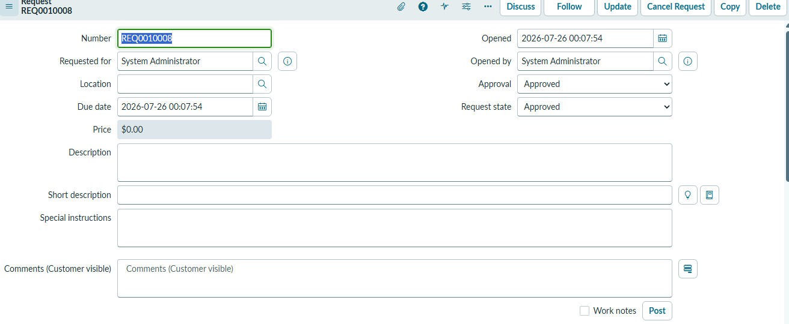

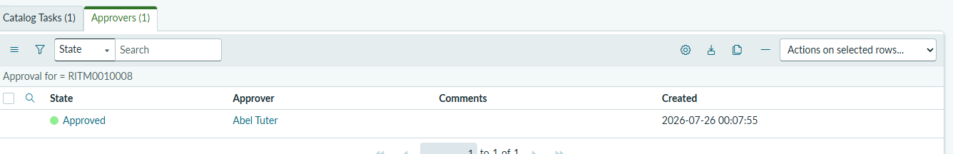

Conclusion
This project successfully creates a ServiceNow solution for requesting software through the Service Catalog. The workflow automatically handles approvals, creates a fulfillment task, and closes the request after the task is completed. The solution reduces manual work, improves efficiency, and ensures that software requests follow the correct approval process. It can also be enhanced in the future with additional approvals, notifications, or integrations as needed

